**Eclipse Installation:**

**Step1** : Goto below link for eclipse download

<https://www.eclipse.org/downloads/packages/release>

**Step2:** Choose eclipse version:

We prefer: photon/Oxygen

**Step3:** Choose R packages

Click on R Packages

**Step4:** Choose first option that is : [Eclipse IDE for Java EE Developers](https://www.eclipse.org/downloads/packages/release/photon/r/eclipse-ide-java-ee-developers)

**Step5:** choose system 64-bit/32-bit

**Step6:** click on download

**Step7:** Goto download folder and extract downloaded file

**Step8:** click on extracted folder ->eclipse->eclipse(Blue color icon)

**Eclipse steps:**

Step1:

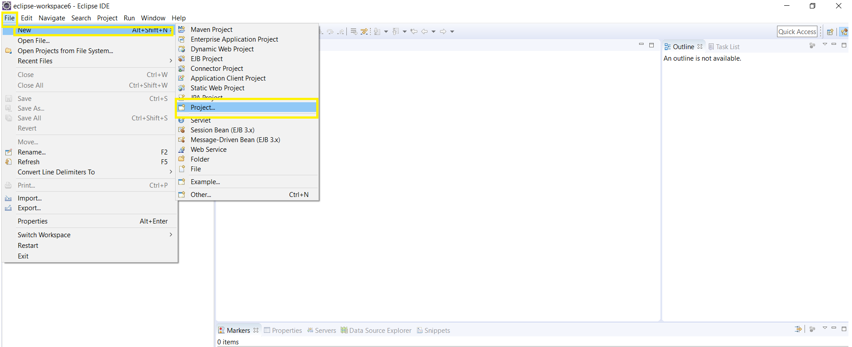

Step2:

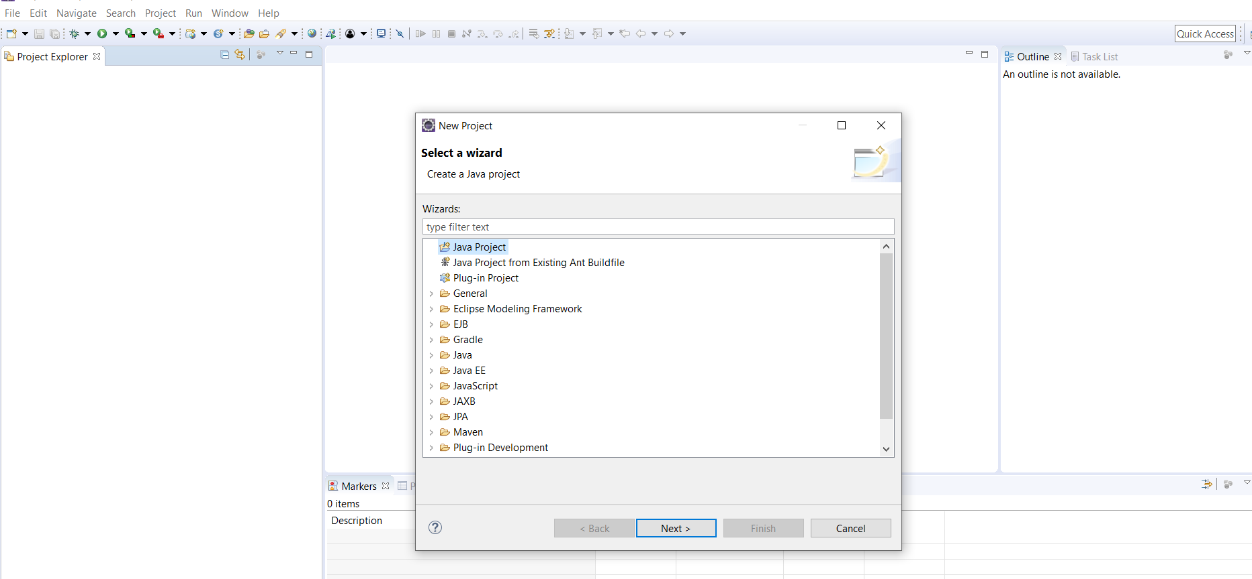

Step2:

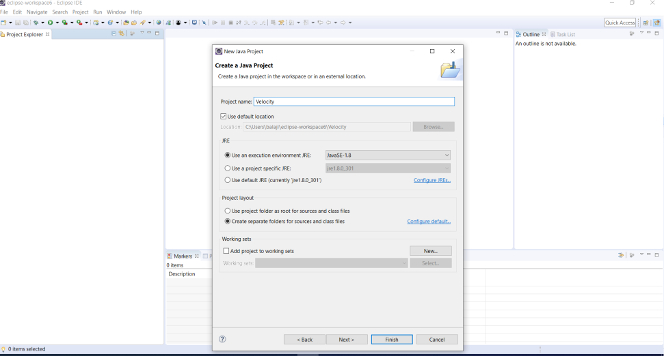

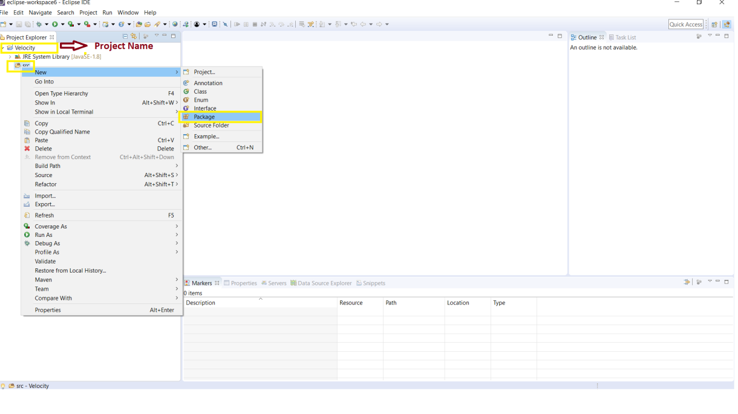

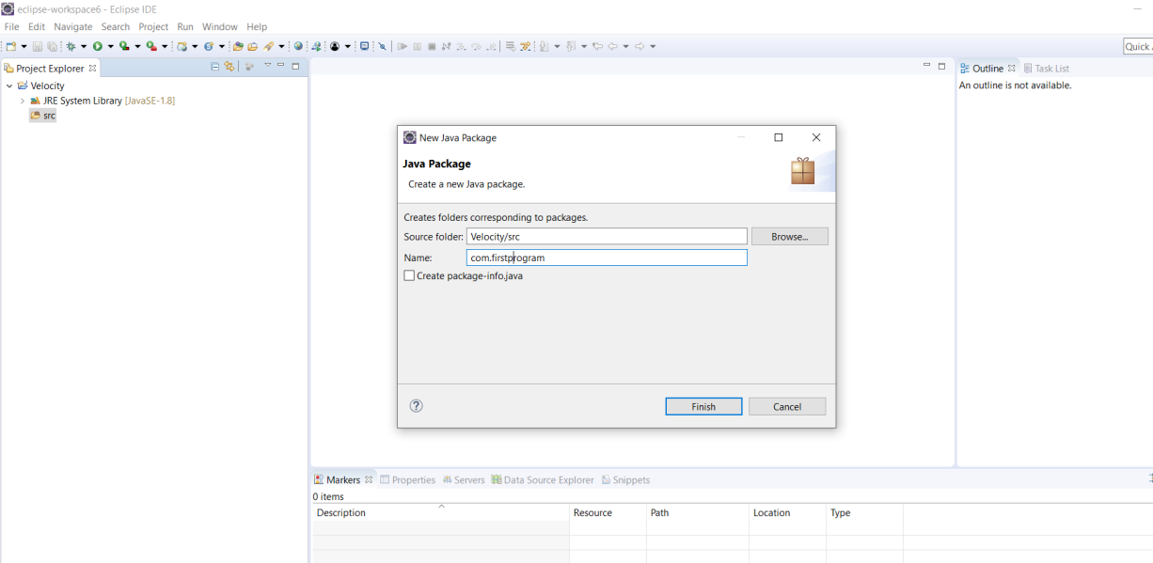

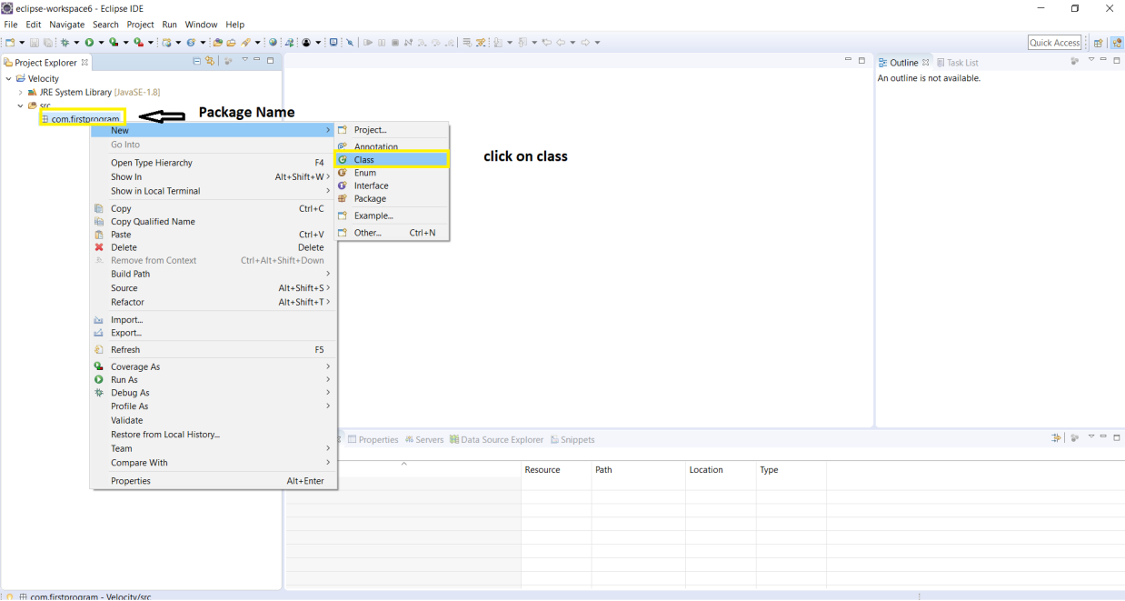

Verify Eclipse is working:

**First Program:**

Step 1: Create Project

Step2:Create Package ->Go to Project -> Right click ->click on package-> type package name ->finish

Step3: Create class: Got to packagename -> Right click-> click on class -> type class name -> Finish

Step4: Go to create file -> type in class body

**Create main method**: type main -> Press ctrl+ space -> popup will display -> select main method

**public** **static** **void** main(String[] args) {

}

**Create Print statement**: type syso -> Press ctrl+space -> Popup will display -> select syste.out.println

**public** **static** **void** main(String[] args) {

System.***out***.println("Welocme to JAva.......");

}

Finally class will be:

**public** **class** JavaProg {

**public** **static** **void** main(String[] args) {

System.***out***.println("Welocme to JAva.......");

}

}

Run Program:

Go to Run -> Click on Run as ->Java Application